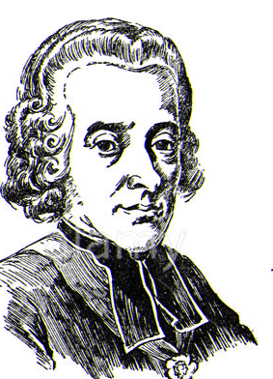
INCUMBENTS LIST
For the parish of
Holt

The Parish Church of
St. KATHARINE
Holt

Though Colstan the priest was among
the Abbess of Shaftesbury's tenants
in Holt between the years 1135~1189,
and licence to hear divine service
was given in 1334, Holt was a Chapelry
of Bradford-on-Avon until the year 1846
when it was made a separate parish. A
perpetual curacy in June 1846. There
are no official lists of curates before
1814. The following have been perpetual
curates or vicars of Holt St. Katharine.

YEAR | SURNAME | GIVEN NAMES | PATRON | NOTES
1846~1850 | Gregory | James Charles
1850~1863 | Turner | Charles
1863~1866 | Lambert | Richard Umfraville |  | Priest in Charge
1866~1901 | Moseley | Herbert Henry
1901~1913 | Metford | George Augustus Seymour
1914~1932 | Roberts | Thomas
1932~1954 | Brewis | Charles Frederick Harrison
1954~1955 | William | Thomas Alun
1956~1960 | Brewis | Edward Lawson
1961~1967 | Batchelor | Kenneth Burder
1968~1978 | Howlett | George Harrington
1978~1986 | Dunnings | Reuben Edward

YEAR | SURNAME | GIVEN NAMES | PATRON | NOTES
1986~1995 | Fiske | Paul Francis Brading
1996~2005 | Hart | Ronald George
2006~ | Evans | Andrew Eric

Source: Holt St. Katharine

