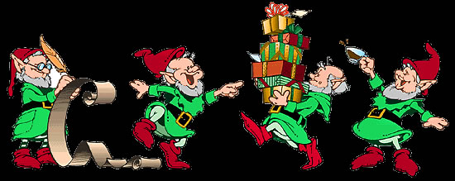
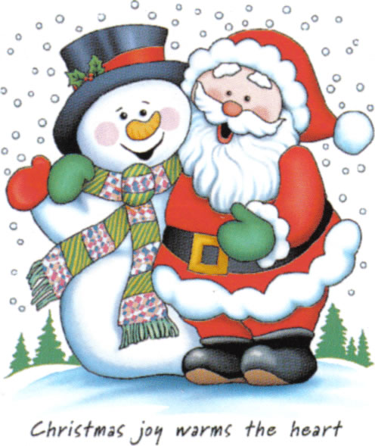


Have a Go at the Wiltshire Pub Quiz - Gentlemen Enjoy Your Beer & Ladies Your Gin & Tonics

The answer to all of these questions can be found either by looing on the Wiltshire OPC Website or via Google. There are no prizes - just for fun over the festive period. Submit your answer to Teresa Lewis/Teresa Sheridan either by e-mail or on the FB page.

QUESTIONS
1. This pub in Salisbury has a severed human hand on display
2. This colourful named public house is one of Quidhamptons’ closed inns
3. The Longs Arms is a pub restaurant in this village
4. The Chequeurs was a public house still open here in 1939 now in residential use.
5. Hindon & Upton Scudamore both have a pub with this name.
6. Malmesbury and which other parish has a pub named The Radnor Arms
7. Unusual name for a public house in a landlocked county, this pub was in use during the 1870s in the parish of Yatton Keynell
8. This parish has had public houses named The Plough, The Royal Oak and the Rose & Crown
9. Thirsty people in this parish, it has 8 public houses two of which are the Dockle Farmhouse and The Rat Trap
10. Being the only public house in the Garrison Town of Tidworth, this must be local to many servicemen and women.
11. Close to the border with Hampshire, the 16th century Queens Head is a pub restaurant in this Wiltshire village
12. You could be found in this Melksham Pub
13. The Flemish Weaver in this town has been voted the most expensive in Wiltshire
14. Tollard Royal has only one pub what is it called
15. This Pub/Restaurant/Hotel is purported to be the oldest purpose built hotel in England. What is the name of this establishment and in which town can it be found. One clue is that it sits next door to an abbey.
16. The George Inn claims to be the oldest in Wiltshire. Where can it be found.
17. This coaching inn built in Devizes in 1737 doesn’t have far to go for its beer supplies.
18. The Bluebell Inn is now converted into a residence. It had closed by 1920, but in which village did it serve the parishioners.
19. Bell Inn, Masons Arms and Queen Victoria are all closed pubs in which village. The Blue Boar and The Crown remain open.
20. Venue for the 2020 Wiltshire OPC get together. Hope to see you all there.
21. This is a pub with a difference, it is advertised as pigs pies, pints and pillows. You will find this establishment on an organic farm in the north of the county near to Swindon. Name the pub and the parish it is found in.
22. Situated near the Guildhall Hall Square & Market Place, Salisbury. This pub takes its name from the street location it is on.
23. Chippenham has at least 22 public houses. Name the one you would more likely find across the Severn Bridge heading west.
24. The Dumb Post Inn is the only pub in this village. I wonder how many times my ancestors used this establishment.
25. Name the four closed public houses in Tisbury.
26. The Red Lion in this mystic village is said to be Wiltshire’s most haunted.
27. Who was the landlord of the New Inn, Milton Lilbourne in 1855.
28. The Crown Inn is just a short walk away from the Church of St. Mary the Virgin in this clerical sounding parish.
29. In which year were G. Johnson & A. Lee landlords of the Crown Inn and New Inn in Ogbourne St. George.
30. The Bell & Crown on New Road, is situated in this village in Southwest Wiltshire and is very close to the Dorset and Somerset borders.
31. This now closed pub in Ramsbury was often used for coroners inquests to take place.
32. Thomas Burry, the murderous landlord from Lydeway was landlord of this public house. He is reputed to be Wiltshire’s first serial killer.
33. This public house between Derry Hill & Pewham had to close in 2009 when a car plunged into its doorway.
34. The Ghost Train Pub is now closed but the sign remains. What was its former names and where can you find it.
35. The County Ground Hotel can be found where in Wiltshire.
36. Two named phenomena are meant to haunt the Jolly Tar in Hannington - Can you name them. Research however has not been able to definitively connect these names to the pub or former farmhouse that it once was.
37. Where would you find the Wiltshire Yeoman.
38. This colourful pub in West Wellow could be named after a dog, a car or just someone wandering aimlessly.
39. Now then, Who Would’ve Thought of That being here.
40. No, you haven’t been transported to the set of Emmerdale, but to the village of Sutton Veny. What pub are you in.
41. Dogs are allowed on leads, children if sedate(d) is one of the signs at this pretty thatched pub named after a Queen and Her Consort, although it must have been renamed since it was built in the 16th century. Where is it.
42. The most Christmassy pub I could find is in Lacock. What is it called.
43. In 1889 who was the innkeeper at the Lamb Inn, Nomansland
44. What was abandoned at the Pelican Inn, Stapleford in 1835.
45. Thomas Hardiman was the publican at this Alderbury (Whaddon) pub. Name the pub and the year.
46. In 1915 Walter Witt was landlord and in 1939 Annie Witt was landlady of this Hanging Langford public house. Name it.
47. What was the former name of the Hullavington Arms in Hullavington, the pub was saved from closure in 2017 and renamed.
48. At this time of year you may find the odd partridge in this Whitley Pub.
49. The 15th century George & Dragon is a thatched pub on the A360 between Devizes and Lavington. What Parish is it in?
50. This closed pub in Market Lavington would have made with want to sing a little………

The Wiltshire OPC Team Wish You All a Very Merry Christmas and Happy New Year.
Please Submit your answers to Teresa Lewis and mark them as Xmas Quiz 2019.
lewisteresa33@hotmail.co.uk

