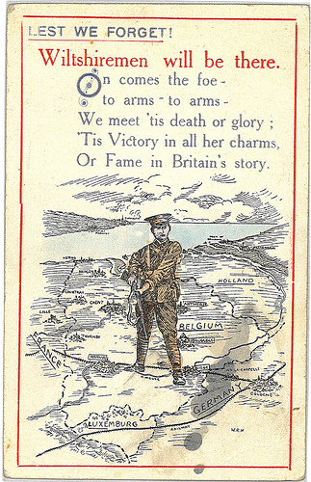
Wiltshire
at War

Parish

Body of text here:

