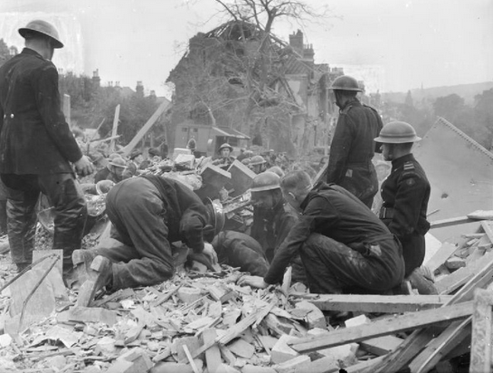
Parish

World War II Civilian Deaths 1939-1945

Surname | Name | Age at Death | Family Connection | Date of Death | Place of Death | Other information

