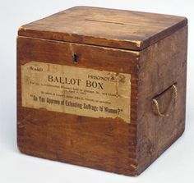

List of Voters for the (Constituency) Division of the County of Wilts. (year)

The List of Persons entitled to vote in the Election of Knights of the Shire for the (Constituency) DIVISION of the County of Wilts, in respect of Property situate within the said Division.

Parish of (name of parish) in the Hundred of (name of Hundred)

Surname | Given Names | Title | Place of Abode | Nature of Qualification | Street, Lane, or other Place in this Parish, where the Property is situate, or name of Property, or Name of the Tenant

