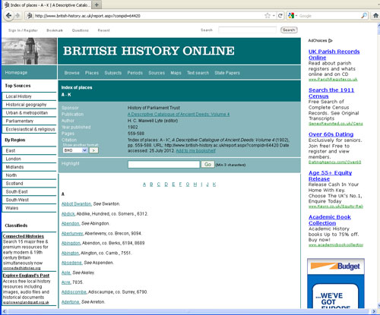

Using Information from other Websites

When using information from web sites such as those featured in the heading images above it is important that the following notes should be followed.
Firstly ensure that if information is used from any source that the information is permitted to be used and what references to that source is required by the copyright holder to be included in the new document. Sometimes it is sufficient to name the source at the bottom of the transcription.
Technically speaking - you will all be aware from e-mails we have sent out in the past and from guidance notes - that websites use code to produce text that we see as a “normal page” - this code is usually an html code.
If an article is cut and pasted from a document from a web site rather than transcribed you will notice that at the top right hand corner a small square may appear.
This means that although the page looks like text it is in fact a document of converted html code. The code will also include instructions such as fonts and size used, where to use italics, colours used in backgrounds etc. All this is then converted to the new document you are creating. (Copyright then may be an issue)
This could also effectively crash our own website so it is highly recommended that old fashioned typing is required to produce what essentially becomes your own document provided it is not exactly the same as produced by the original source and reference to the source material should be added.
In other words when using long texts from web sites we cannot just cut and paste. Remember our own templates are formatted for our web site use.
It is also the idea of the original OPC projects that information should be provided in one place - not linking to external web pages. One main reason for this is that by linking to documents externally means that we have no control over the information. The information provider may decide to close or remove the web page thus creating broken links on our own website. Some web pages may not be maintained and become obsolete again creating broken links within our own pages.
All OPCs are asked to occasionally check any external links on the their pages to ensure none are broken.

