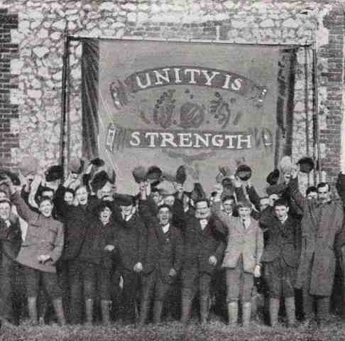
Trades Unions Yearly Admissions

The origins of trade unions can be traced back to 18th century Britain, where the rapid expansion of industrial society then taking place, drew women, children, rural workers and immigrants into the work force in large numbers and in new roles. This pool of unskilled and semi-skilled labour spontaneously organized in fits and starts throughout its beginnings and would later be an important arena for the development of trade unions. Trade unions have sometimes been seen as successors to the guilds of medieval Europe, though the relationship between the two is disputed, as the masters of the guilds employed workers (apprentices and journeymen) who were not allowed to organize.

The first attempts at setting up a national general union were made in the 1820s and 30's. The National Association for the Protection of Labour was established in 1830 by John Doherty, after an apparently unsuccessful attempt to create a similar national presence with the National Union of Cotton-spinners. The Association quickly enrolled approximately 150 unions, consisting mostly of textile related unions, but also including mechanics, blacksmiths, and various others.

More permanent trade unions were established from the 1850s, better resourced but often less radical.

Recent historical research puts forward the view that trade unions are part of a broader movement of benefit societies, which includes medieval guilds, Freemasons, Oddfellows, friendly societies, and other fraternal organizations.

 | Surname | Given Names | Date of Birth |  | Date of Death
 | Surname | Given Names | Year | Date | Year | Date
Member Details
Address/Residence of Member
 | Year | Date | Age
Date of Admission to Union
Name of Union
Union Branch and Number
Industry & Trade & Years in Trade
Name of Company Where Employed
Location Employed at
Union Branch Transfer | Year | Date | Branch & Number
Union Exclusion | Year | Date | Cause for Exclusion
Next of Kin | Surname | Given Names | Relationship to Member
Address/Residence of Next of Kin
Marriage After Admission | Year | Date | Location
Change of Next of Kin | Year | Date | Relationship to Member
Change of Next of Kin | Surname | Given Name
Address/Residence of New Next of Kin
Further Date of Admission | Year | Date | Age
Name of Union
Union Branch and Number
Industry & Trade & Years in Trade
Name of Company Where Employed
Location Employed at
Further Date of Admission | Year | Date | Age
Name of Union
Union Branch and Number
Industry & Trade & Years in Trade
Name of Company Where Employed
Location Employed at

OPC Notes:

