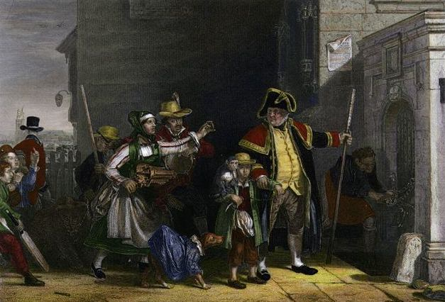
Settlement
Examinations

(Parish)

