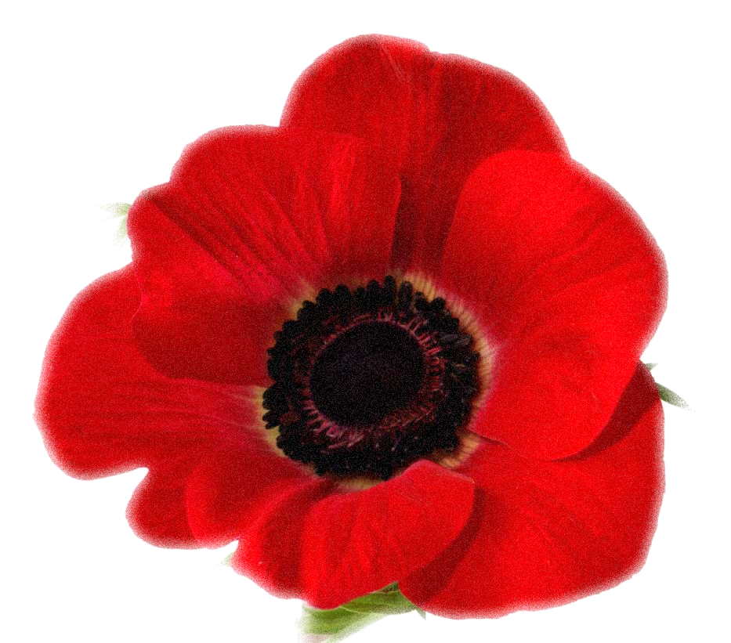
(Parish)
World War I Casualty Biographies

