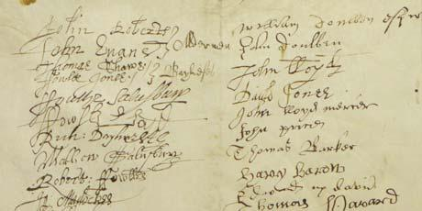
(Parish)
Protestation Return of 1641/42

The Protestation Returns relate to the years 1641/42, around the start of the Civil War. It was an Oath of loyalty to the King. The incumbent of each parish was to read the protestation to his parishioners and all men over the age of 18 had to sign the oath but the women were not usually asked to sign.

The Protestation itself runs in the following terms :-
"I (A. B.) doe, in the presence of Almightie God, promise, vow, and protest to maintaine and defend, so farre as lawfullie I may, with my Hfe, power, and estate, the trne Reformed Protestant Religion
expressed in the Doctrine of the Church of England, against all Poperie and Popish Innovations within this Realme contrarie to the same Doctrine and according to the dutie of my Allegiance [to] his Ma'ties
Royall person, honor, and estate. As also the Power and Privileges of Parliament, the lawfull rights and Liberties of the subject, and every person that maketh this Protestation in whatsoever hee shall doe in the lawfull pursuence of ye same. And to my power, and as farre as lawfullie I may, I will oppose, and by all good waies and meanes indeavor to bring to condigne punishment all such as shall either by Force, Practise, Counsells, Plotts, Conspiracies, or otherwise do anie thing in this present Protestation contained. And further, that I shall in all Just and honorable waies endeavor to preserve ye Vnion and Peace between the three Kingdomes of England, Scotland, and heland.
And neither for hope, feare, nor other respect, reliquish this promise, vow, and Protestation."

Those who took the oath

SURNAME | GIVEN NAMES | OTHER | POSITION
To add more rows place cursor outside grid of last entry and press enter

About the Protestation Returns

The Protestation Returns of 1642 are lists of males over the age of eighteen who took, or did not take, an oath ‘to live and die for the true Protestant religion, the liberties and rights of subjects and the privilege of Parliaments’. These lists were usually compiled by parish, or township, within hundred, or wapentake. They are of importance to local historians for estimating populations, to genealogists trying to find an ancestor immediately before the English Civil War and for scholars interested in surname distributions

