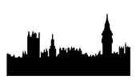

(The Poll For The Election of
Two Knights of the Shire
For The County of Wilts. Change Text to Suit)
On the (Date)

(Name, Sherriff)

CANDIDATES

Name of Candidate 1

Name of Candidate 2

Name of Candidate 3

Parish
Surname | Given Names | Other | Abode | Voted for  (Surname) | Voted for | Voted for

Those Persons whose votes are recorded as *** denotes that the voter had died before the election took place or did not vote for some other reason.

Please not new lines may be added by placing cursor outside the last cell of the last row and pressing enter for as many new line required

