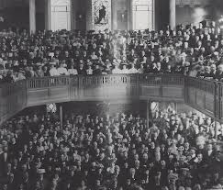
Non- Conformist News
Parish
Image may be changed to suit

