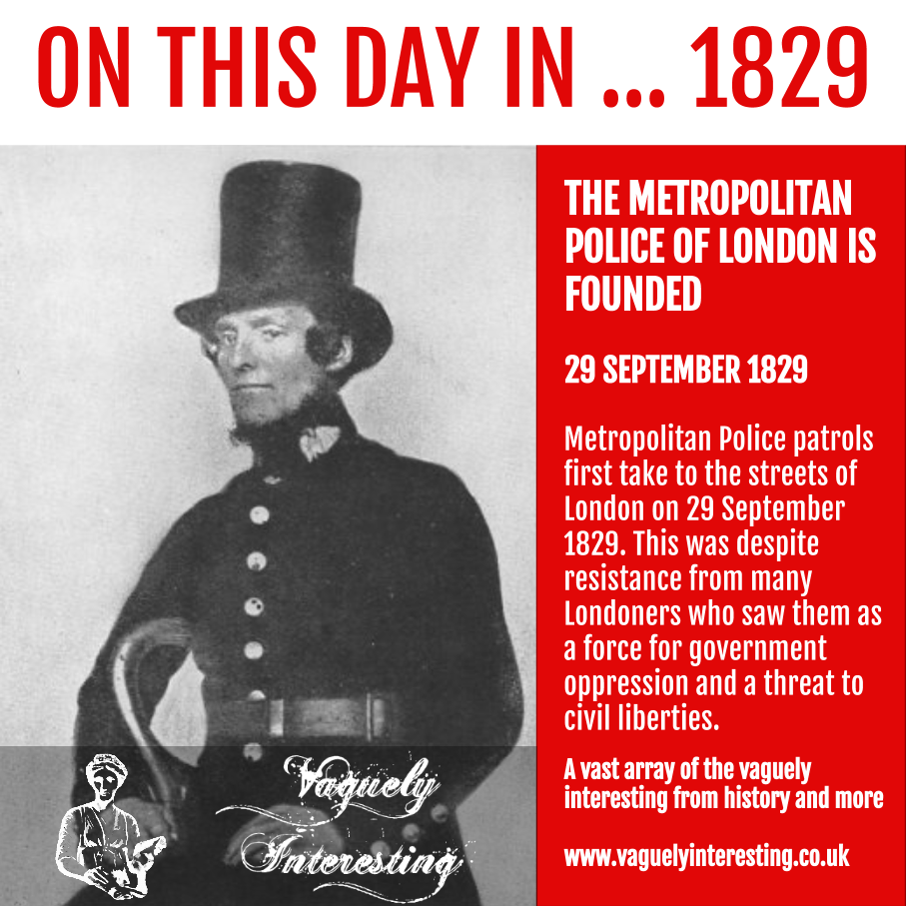

Below is a list of areas covered within the Metropolitan Police Structure. It shows some of the changes made as the force became bigger and the population it covered expanded.

No. 1 District:
G – Finsbury
H – Whitechapel;
K – Stepney;
N – Islington
and Thames Division

No. 2 District:
D – Marylebone;
E – Holborn;
S – Hampstead;
X – Paddington;
Y – Highgate

No. 3 District:
A – Whitehall;
B – Westminster;
C – St James’s;
T – Kensington;
V – Wandsworth

No. 4 District:
L – Lambeth;
M – Southwark;
P – Camberwell;
R – Greenwich;
W – Clapham

F Division – Covent Garden

J Division – Bethnal Green – added in 1886

Z Division – Croydon – was formed in 1921. Croydon had previously been included in W Division

Q Division – Wembley – was formed in 1965. Wembley was previously X Division

