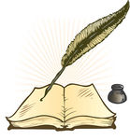
Wiltshire Marriage Licence Bonds

(Insert Parish here)

Year | Date | Groom’s Surname | Given Name | Age | Status | Occupation | Groom’s Parish | Bride’s Surname | Given Name | Age | Status | Occupation | Bride’s Parish | Notes

