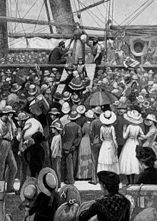

Emigration

(Record Set)
Surname
Given Names
Birth Year
Age on Entry
Gender
Occupation
Native Place and County
Parents
Town of Settlement
Arrival Date
Place arrived from
Relatives in the Alaska
Remarks/Description of Entrant

OPC Note:

