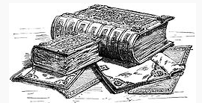
DOMESDAY BOOK
(PARISH)
The Domesday Book is a record of the great survey which was completed in 1086, of much of England and parts of Wales.
The survey was executed for William I of England (William the Conqueror) to determine how much each landholder had in land & livestock, and what it was worth. From this it could be determined how much tax was liable. The judgement of the Domesday assessors was final – whatever was written in the books about who held what material wealth or what it was worth, was law and no appeal was available. It was written in Latin and the text was highly abbreviated. The Domesday books were referred to as “the Book of Judgement” “because its decisions, like those of the Last Judgement, are unalterable”.
Section of the Domesday Book relating to (Parish name here)

Hundred
County
Total Population
Total Tax assessed
Taxable Units
Value
Households
Ploughland
Other resources
Lord in 1066
Lord in 1086
Tenant-in-chief in 1086
Phillimore reference

