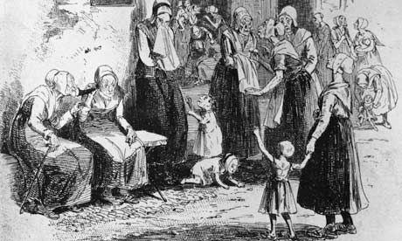
Wiltshire
Workhouses

Parish

Body of text here:

