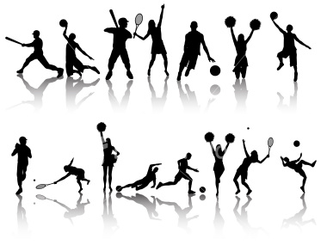
(Replace with an appropriate image if needed)
Parish
Sports

