RMS Carmania - Cunard Line (Ship Image to be changed per record)
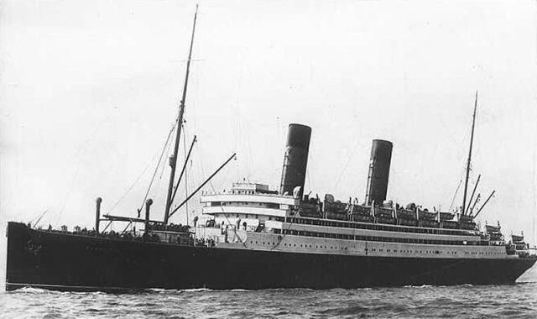
Ships Crew Detail
Particulars of Engagement
Surname |  |  |  |  | Given Names | Age | Date of Birth |  | Place of Birth
 |  |  |  |  | Given Names | Age | Year | Date
Port of Engagement |  |  |  |  | Address in Port |  |  | Home Address
Ship Last Served Aboard |  |  |  |  | Year Discharged  from Last Ship | Date and Place of Signing the Agreement |  |  | Capacity in which Engaged
 |  |  |  |  | Year Discharged  from Last Ship | Place | Year | Date
No. of Certificate & Reserve Commission or R. V.2 |  |  |  |  | Date and Hour to Be Aboard |  | Amount of Wages |  | Amount of Wages Advanced upon Engagement
 |  |  |  |  | Date | Time | Weekly | Monthly
Amount of Weekly or Monthly Allotment |  |  |  |  | Name or Initials of Officer Before Whom Seaman is Engaged
Weekly |  | Monthly
Particulars of Discharge
Date and Place of Discharge |  |  |  |  |  | Reason for Discharge |  | Balance of Wages Paid on Discharge
Year |  |  | Date |  | Place |  |  | Balance of Wages Paid on Discharge

OPC Note:
Some of the detail above has been added from other sources such as Census and BMD records.

