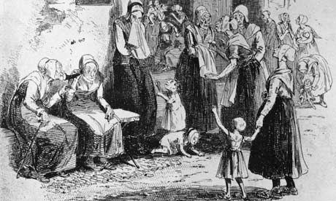
Parish

Wiltshire Removal Orders
Wiltshire Removal Orders give details of 20, 593 people removed from Wiltshire under the 1662 Poor Law Relief Act between 1670 and 1890.

The records show a person’s parish of settlement as well as the place they were being removed to in order to receive poor relief. These facts would have been ascertained through a Pauper Examination conducted by local justices of the peace. The place of settlement was generally considered the place where you were born or where you were best known. For a married woman this would be where her husband was from, for a child it would be the father’s parish. It was also noted whether the person was the head of household – if a woman is listed as such it would generally mean that she was either a widow or an unmarried mother.

People usually moved between parishes in the same county but some came from further afield. There are several families, for example, sent back to Ireland and to Wales. The Wiltshire removal orders also show those removed to Wiltshire from elsewhere.

Year | Date | Surname | Name | Removed From | Removed To | Head of Household & Other details | Witshire Record Office Reference

