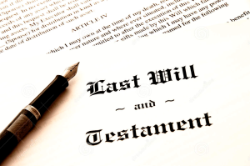
Probate & Estate Notices
Parish and year if required

