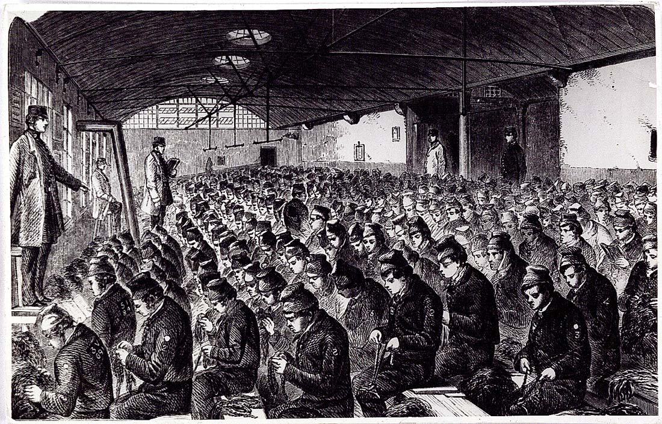

Individual Prison Record
Surname | Given Name | Age | Place of Conviction | Date of Conviction
 |  |  |  | Year | Date
Crime Committed |  |  | Type and Length of Sentence
Physical Description |  |  |  | Number of Children | Occupation or Trade
Height | Hair Colour | Complexion Type | Identifying Marks | Number of Children | Occupation or Trade
Parish of Residence |  |  | Notes

