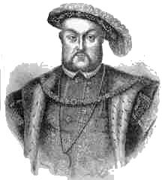

North Wiltshire Muster Roll
Anno 30 Henry VIII (Year 1539)

In Tudor times each village was responsible for maintaining the necessary arms to defend themselves - this was known as the furnishing of harness. Muster commissioners would inspect the harness (which would include long bows, bills, salets (helmets), brigandines (torso armour) and gorgets (neck and shoulder protectors) and ensure each individual was also assessed with his quota of the cost. The muster roll records who owned the arms, along with value of land (valor terr et tent) or value of goods (valor bonorum) held by the other residents of the village who were liable to provide financial support if necessary. (These values have not been transcribed in the Wiltshire Roll)

There were two main arms used in this period. The bill had a point at one end and a blade at the side, so had a dual purpose in battle, while the bow was a long bow used for archery.
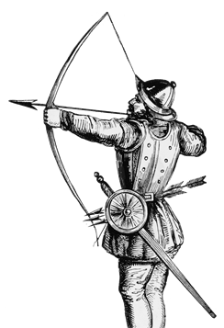
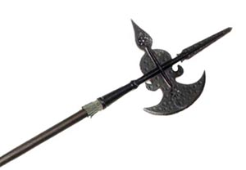
The Hundred of
The (Parish or Tithing) of

Surname | Given Name | Status | Notes

For other transcripts of these records visit Rootschat

