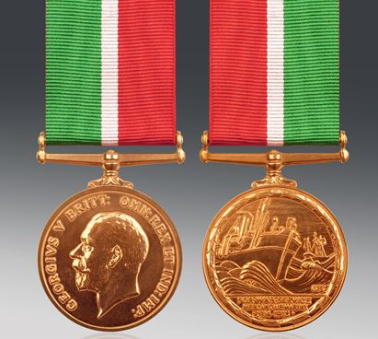

(Parish)
Mercantile Marine Medals

(Recipient)

Mercantile Marine WWI Medal

Surname |  | Certif. or Dis. A.
Christian names |  | RS2 No.
Place of birth |  | Year of Birth
Mercantile Marine Ribbon Issued |  | to M.M.O.
British Medal Ribbon issued |  | to M.M.O.
Mercantile Marine Medal Issued |  | to M.M.O.
British Medal issued |  | to M.M.O.
Clasps issued

