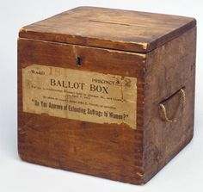
List of Voters for the Southern Division of the County of Wilts. 1832

The List of Persons entitled to vote in the Election of Knights of the Shire for the SOUTHERN DIVISION of the County of Wilts, in respect of Property situate within the said Division.

Parish of [parish in the Hundred ]

Number | Name | Place of Abode | Nature of Qualification | Street, Lane, or other Place in this Parish, where the Property is situate, or name of Property, or Name of the Tenant

Some residents of [Parish] were entitled to vote in other parishes:

Parish of [Parish in the Hundred of ]

Parish of [parish in the Hundred of ]

