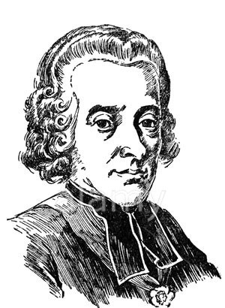
INCUMBENTS LIST
For the parish of
(Parish Name)

YEAR | SURNAME | GIVEN NAMES | PATRON | NOTES

