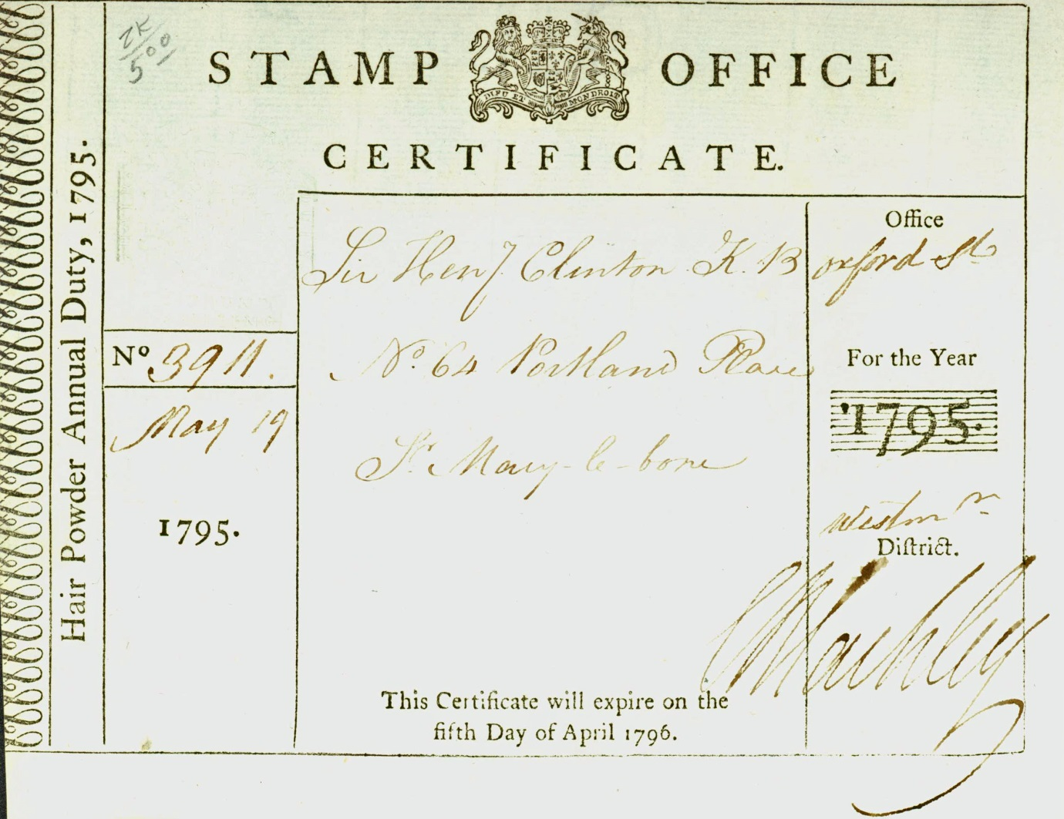

Typical Hair Powder Tax Certificate.

Duty on Hair Powder Act 1795 (35 Geo. III, c. 49) was an Act of the Parliament of Great Britain levying a tax on hair powder. It was repealed in 1869.

The Act stated that everyone wishing to use hair powder must, from 5 May 1795, visit a stamp office to enter their name and pay for an annual certificate costing one guinea. Certain exemptions were included: the Royal Family and their servants, clergymen with an income of under £100 a year, subalterns, non-commissioned officers, privates in the army, artillery, militia, mariners, engineers, fencibles, officers in the navy below commander, yeomanry, and volunteers. A father with more than two unmarried daughters might buy two certificates which would be valid for any number he stated at the stamp office. The master of a household might buy a certificate for a member of his servants which would also be valid for their successors within that year. The use of hair powder had been declining and the tax hastened its near death. In 1812 46,684 people still paid the tax, in 1855 only 997 did, and almost all of these were servants. By the time it was repealed in 1869 it yielded an annual revenue of £1000.The Hair Powder Certificates, etc. Act 1795 (35 Geo. III, c. 112) was passed later in the same session of Parliament to allow people more time to apply for certificates.

Year | Date | Surname | Given Name | Position

