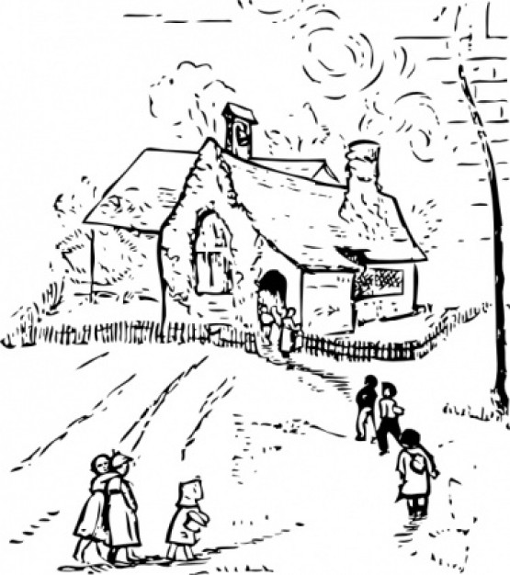
(Image may be replaced if required)

Education & School News
for the Parish of (Name) for the Years (Date Range)

