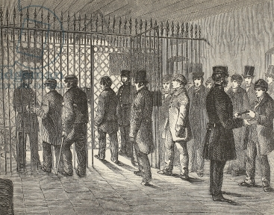
Crime Reports

Parish
(Year Range)

The above image may be changed to suit the crime.

