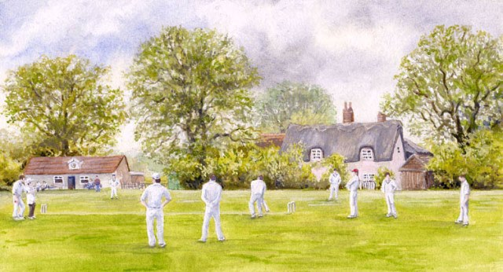

(Home v Away)
(Match Report Here)

(Home Team) |  | First Innings |  |  |  |  |  | Second Innings
Name |  |  | Dismissed |  |  |  | Score | Dismissed |  |  |  |  | Score
Extras
TOTAL

Away Team |  | First Innings |  |  |  |  |  | Second Innings
Name |  |  | Dismissed |  |  |  | Score | Dismissed |  |  | Score
Extras
TOTAL

(Source)

