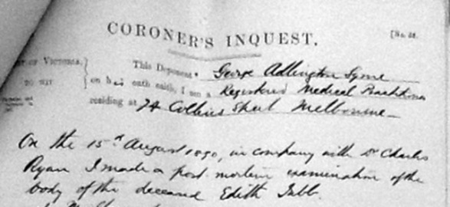
Coroners Bills
1752-1796

(Parish)

County coroners were introduced in England in around 1194 once established other boroughs and liberties sought the right to have their own coroner. Often in Medieval times the coroner also assumed the role of the sheriff and his duties weren't limited to holding inquests on dead bodies although almost a full time post they were unpaid for the duties apart from those that were deemed murder of manslaughter when they would receive 13s. 4d. From the 24th June 1752 a law was passed allowing the coroner to claim £1 for every inquest they attended not held in a gaol and also to claim 9d per mile travel allowance from the place of residence. Inquests held in any gaol were performed at a rate totalling no more than £1. These costs were to be paid from the county rates. In cases of homicide the coroner also received the former fee of 13s. 4d. The coroners submitted their bills at the quarter session sittings for approval.

Year | Date | Surname | Given Names | Coroner |  | Details of Inquest | Place of Inquest | No. of Miles  Travelled | Coroners  Bill |  |  | Notes
 |  |  |  | Surname | Given Names | Details of Inquest | Place of Inquest | No. of Miles  Travelled | £ | s | d | Notes

