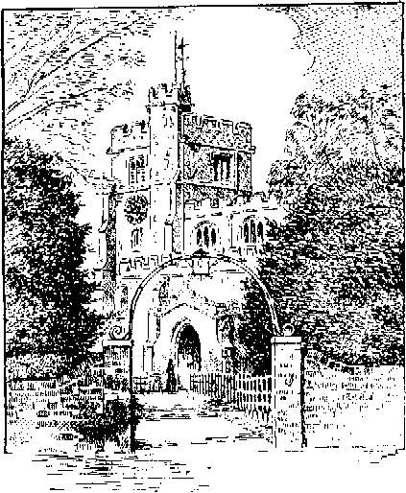
Or add image of parish church here
Parish Church
News
Parish

