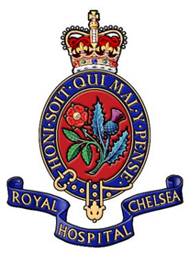
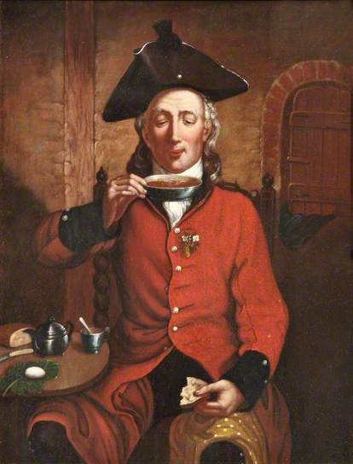
Chelsea Pensioners
(Date Range)

(Parish)

Until the 17th century the state made no specific provision for old and injured soldiers.
During the reign of Queen Elizabeth I it was recognised that provision needed to be made for poor, sick and disabled soldiers. This led to an Act of Parliament, passed in 1593, that levied a weekly tax on parishes for the relief of soldiers and sailors.
By 1673 it was becoming increasingly apparent that some soldiers were no longer fit for service. In 1681, King Charles issued a Royal Warrant authorising the building of the Royal Hospital Chelsea to care for those 'broken by age or war'.
Sir Christopher Wren was commissioned to design and erect the building. Sir Stephen Fox was commissioned to secure the funds necessary to progress the build.
The chosen site, set adjacent to the River Thames in the countryside of Chelsea contained the uncompleted building of the former 'Chelsey College'.
During the reign of King William III and Queen Mary II, the Royal Hospital was still under construction, so they introduced a system for distribution of army pensions in 1689. The pension was to be made available to all former soldiers who had been injured in service, or who had served for more than 20 years.
In 1692 work was finally completed and the first Chelsea Pensioners were admitted in February 1692 and by the end of March the full complement of 476 were in residence. However there were more pensioners than places available in the Hospital. Eligible ex-soldiers who could not be housed in the Hospital were termed out-pensioners, receiving their pension from the Royal Hospital but living outside it. In-pensioners, by contrast, surrendered their army pension and lived within the Royal Hospital.
In 1703, there were only 51 out-pensioners. By 1815 this figure had risen to 36,757. This was due to Napoleonic War Service
The Royal Hospital remained responsible for distributing army pensions until 1955, following which the phrase "out-pensioner" became less common, and "Chelsea pensioner" was used largely to refer to "in-pensioners".
To qualify for a Pension or a place within the hospital you had to satisfy one of two criteria. 1. Be injured whilst on active service. 2. To have served more than 20 years in the service of the country.
In 2009 the first women were admitted to the hospital following a decision in 2007 to modernise the facilities for both men and women use.

For More information about the Chelsea Hospital please visit – Origins and History

Surname
Given Name
Rank
Regiment
Date of Examination | Year | Date
Age
Place of Birth
Years of Service
Occupation on Enlistment
Doctor’s Report of Examination
Character Report
Pension Awarded
Description | Height
Description | Hair
Description | Eyes
Description | Complexion

