How to Layout Your Parish Page
Categories and Suggested Sub Headings and Item Types to be Included Within Categories
Pages are prebuilt for you but to show you the process and hopefully give you an understanding of what is involved we have compiled this guide.
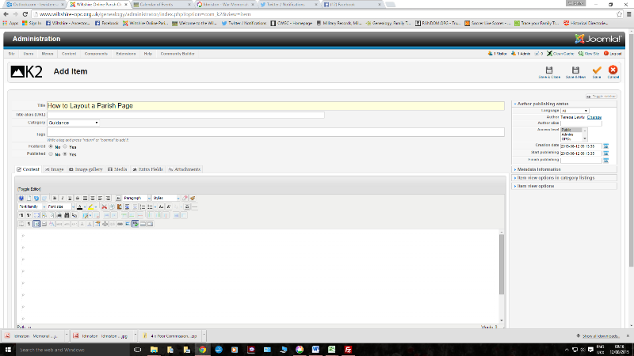

When starting to build a page you will see the above image. Even when the page is built you will notice that there is to the far right of the page a dotted line - this best represents the width of you page and this line should not be exceeded with text and tables. Text will auto wrap - tables will be cut off and not appear in the front end (website) view (In Web site view the first (top) item will be the parish church photograph or other appropriate image. You do not need to bother with that item as admin will have added a photo - if you would like to change that image please consult the administrator who will add whichever image you wish to use.
The next item will be the main parish gallery - this is created through linking the gallery in Picassa to the text on the page. (This is also done by the administrator)
We then add the Main Categories as follows :-
Contiguous Parishes
These are those parishes that have touching borders with the parish - a sub heading of “A Little Further Afield” could be added if the OPC feels it necessary
Web Sites
Any link to an External Website (these should be checked every so often to make sure the web page is still current)
The Parish Church of ………….
Anything related to the church such as lists of incumbents, items about the churchyard, vestry meeting notes, news articles relating to repairs or additions to the interior etc. Obituaries of former vicars could be included here too.
Parish History
Anything related to the parish and community - such as location, population, maps parish council meetings, community festivities such as fetes and celebrations of a national level.
Buildings and Land
Anything referring to buildings such as fires and purchases, sales of house contents, agriculture, farming, listed buildings, public houses, railway development, archaeology, occupants history of buildings
Crime and Legal Matters
Items such as news reports about crime and punishment, court appearances, bastardy examinations, disputes
Directories
Trade Directories such as Kellys and the Post Office, Phone Books etc.
Education
Any item that relates to schools, teachers, inspections, exam results etc.
Emigration and Migration
Parish strays, ethnic communities within a parish etc.
Employment and Business
Newspaper items such as situations vacant and wanted, strikes, significant employers, factories etc.
Miscellaneous Documents
Anything that cannot be placed under another category
Newspaper Snippets
THIS CATEGORY IS NO LONGER USED AND ITEMS DISPERSED TO OTHER CATEGORIES
Non Conformity and Other Places of Worship
Items related to Methodism, Baptist Movement, Salvation Army, Catholicism etc.
People and Parish Notables
Famous People, Lords of the Manor, Birth, Marriage, Death Notices, News items about people other than crime, Inquests, Bankruptcies, etc., Voters Lists, Electoral Rolls
Poor Law, Charity and the Workhouse
Settlement Notices, Overseers and their Accounts, Charity donation and legacies, The Workhouse, etc.
Probate
Parishioners Wills, Probate Indexes, Newspaper ads seeking relatives, Administration Bonds, Probate Inventories, News articles relating to wills etc.
War, Conflict and Military Matters
All items relating to the military during war and peacetime.
Civil Registration
Registration District for parish, news items relating to register offices and registrars
Registers Held at WSHC
List of registers held for Baptisms, Banns, Marriages and Burials
Transcriptions
Baptisms, Banns, Marriages, Burials, Census Returns

Once the main categories have been added the page should look something like the images below
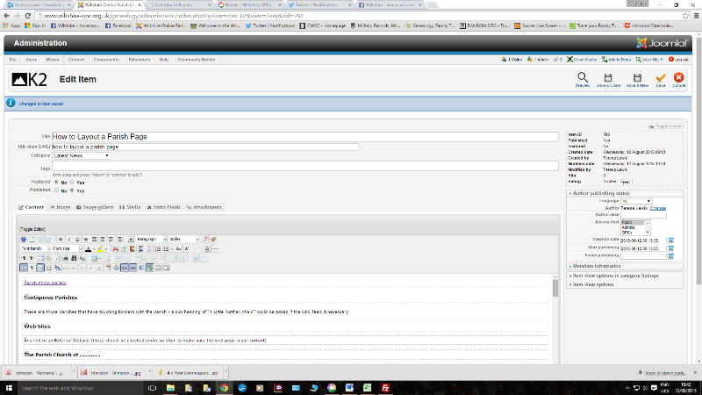
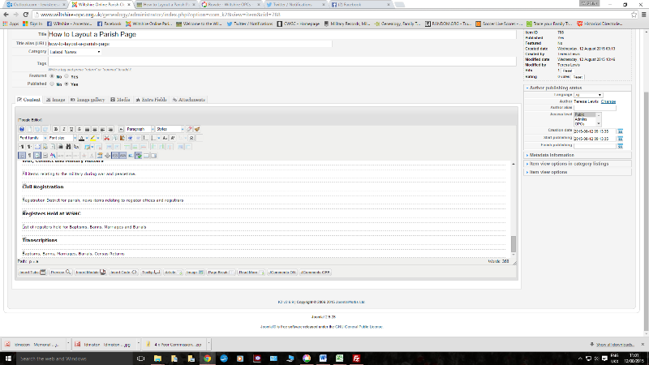

To achieve the different font sizes (these are all pre-set for the website theme). You need to either select the paragraph type from the drop down menu (see image below and then type your text or type the text and then highlight the text you wish to enhance and select the paragraph type from the drop down menu. (the paragraph type is set at p for normal typing).
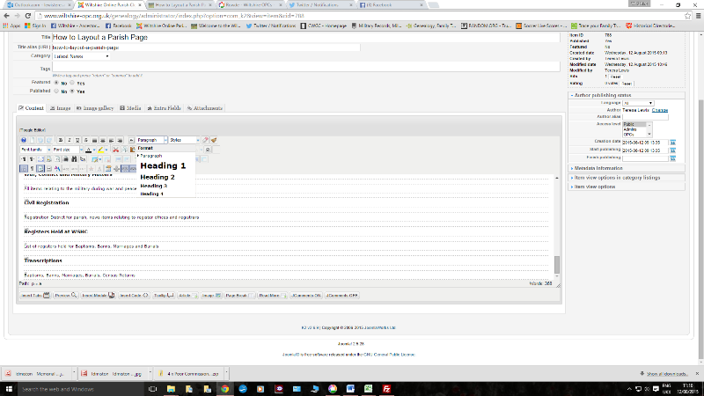

For the main category headings H3 should be selected from the drop down menu. This should not really need to be used by yourselves as the main categories will already be in place.
Now to add some sub- categories
Sub categories should be added using the H4 option from the paragraph drop down menu
A few ideas have been added in the following images
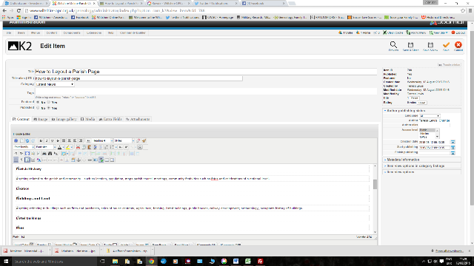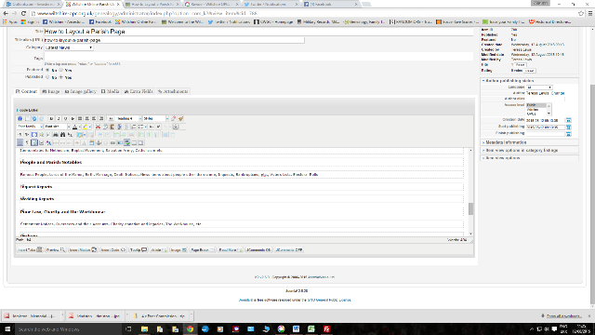

Adding headings within sub categories is slightly more complicated but hopefully the drop down menu for paragraph selection will be adjusted to compensate in the near future. However until the H5 heading category is added - you will need to either ask the administrator to do it for you or you will need to venture into the world of code.
Firstly you need to type the heading for example the name of a public house.
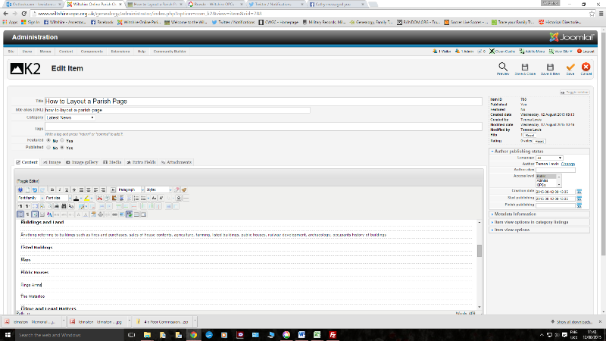
To add the heading command you will now need to o access the code for your page select “toggle editor”
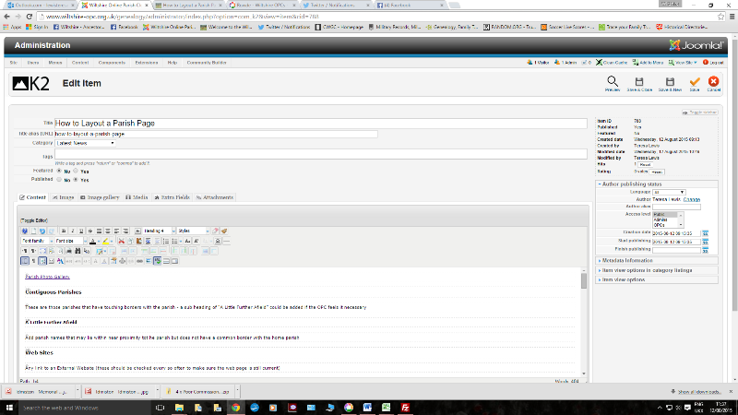
This is what you will see (a little daunting if you have never seen a coded page before) One word of warning though only change what you need to change and be careful not to interfere with anything else or parts of the front end view can be lost or show up as gobbledegook

This is meant to be a guide and not a definitive list
Please feel free to use sub headings within the set categories but please if an item can be generalised it will help with the overall layout of the page
Fonts to be Used for these Categories and Sub Headings Should be as Follows:-
The Parish Name and Names of Places Used in Tabs should be H2
The Main Set Categories should be H3
Sub Categories should be H4
Items within the Sub Categories such as individual names of public houses can be H5 - this may need to be added via the code view of the page. If uncertain leave it as paragraph (p) and ask the administrator to do it for you. Please do not use coloured fonts or bold options

