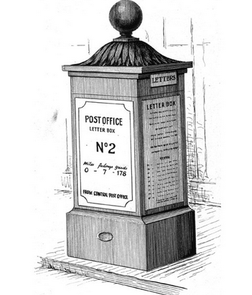
British Postal Services Appointment Books
1737-1969
(Parish)

The British Post Office Appointment Books records when a person began working for the Post Office or started a new position within the Post Office. The Books run from 1737-1969 and contain name, date of appointment, role and location.

Surname | Given Names | Year Appointed | Date of Appointment | Place Appointed From | Place Appointed To | Position

