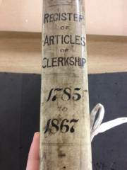
Parish

Articles of Clerkship
The Articles of Clerkship were contracts between an apprentice clerk, who wanted to become an attorney or solicitor, and an attorney who agreed to train the clerk. The contracts were often entered into by fathers (or other sponsors) on their sons’ behalf with terms typically lasting 5 – 7 years.

Surname  of Clerk | Given Names  of Clerk | Surname  of Father | Given Name  of Father | Surname  of Attorney | Given Names  of Attorney | Year of  Filing | Date of  Filing | Notes

