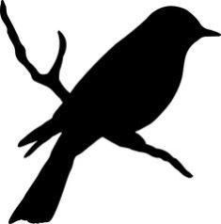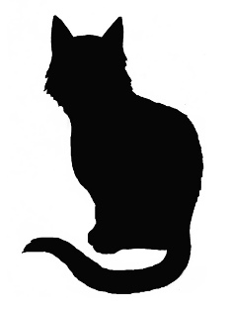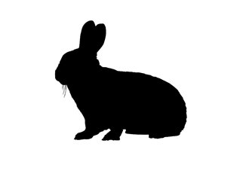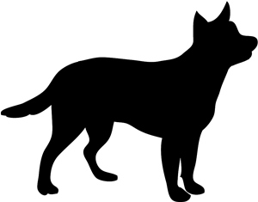

ANIMAL TALES
(Parish) (Year Range)

Animals are part of our family history too. Use this template to record your animal memories within the county of Wiltshire whether pets or wild encounters or to transcribe animal related items from newspapers relevant to the county.

